
TRƯỜNG ĐẠI HỌC CÔNG NGHỆ KỸ THUẬT TP. HCM



MACHINE VISION PROJECT REPORT
TOPIC: Badminton Player Activity Heatmap

GROUP MEMBER NAMES AND ID
PHẠM VĂN THỊNH - 22146056
TRẦN ANH KHƯƠNG - 22146025

MACHINE VISION PROJECT REPORT
Topic: Badminton Player Activity Heatmap
I. Introductions:
1. Background:
In competitive badminton, understanding player movement patterns is crucial for tactical analysis, performance optimization, and opponent scouting. Coaches and analysts need to identify which areas of the court a player dominates, their movement efficiency, and positional tendencies during rallies.
2. Problem statement:
Video footage from standard cameras captures matches from an oblique (side or elevated) angle, creating perspective distortion. This distortion means that:
-Players near the camera appear larger and occupy more pixels.
-Players far from the camera appear smaller.
-Direct pixel coordinates cannot accurately represent real court positions.
Additionally, No advanced ML models are used like Yolo or Mediapipe.
3. Objectives:
-Manually calibrate the court using homography (by clicking 4 corners).
-Detect players using traditional computer vision (background subtraction/motion detection).
-Extract foot positions (lowest point of player blob).
-Transform pixel coordinates to real-world court space.
-Generate heatmap over 10 minutes of match segments.
4. Scope and Limitations:
Input: Static camera video (10 minutes, 30 fps, caulong1.mp4).
Output: JET-colormap heatmap overlaid on a standard badminton court diagram.
Assumptions:
-Camera is fixed (no pan/tilt/zoom during recording).
-Court corners are visible in the first frame.
-Players are the largest moving objects on court.
II. Literature Review & Theoretical Background
1. Perpective Transformation (Homography):
In computer vision, Homography is a projective transformation that maps points from one plane to another. For this project, we map the camera image plane to the real-world court plane.
Mathematical Formulation:
The transformation is defined by a 3×3 matrix H:
$$\left[\begin{matrix}X' \\ Y' \\ W'\end{matrix}\right]=\left[\begin{matrix}h_{11} & h_{12} & h_{13} \\ h_{21} & h_{22} & h_{23} \\ h_{31} & h_{32} & h_{33}\end{matrix}\right]×\left[\begin{matrix}x \\ y \\ 1\end{matrix}\right]$$
Where:
(x, y): pixel coordinates of camera image
(X, Y): real world coordinates
2. Motion detection via background subtraction
Since deep learning models are not allowed, we use Background Subtraction to identify moving objects:
-Algorithm: MOG2 (Mixture of Gaussians) from OpenCV (cv.createBackgroundSubtractorMOG2).
-Principle: Each pixel is modeled as a mixture of Gaussian distributions. Pixels that deviate significantly from the background model are classified as "foreground" (moving objects).
Parameters:
-history = 500: Number of frames used to build the background model.
-varThreshold = 50: Sensitivity threshold for foreground detection.
3. Contour detection and player filtering:
After obtaining the foreground mask:
-Morphological operations remove noise (opening, closing, dilation).
-Contour detection (cv.findContours) identifies connected regions.
Filtering by:
-Area (>800 pixels): Removes small objects (shuttlecock, noise).
-Aspect ratio (height>width): Filters out non-human shapes.
-Minimum height (30 pixels): Removes small false positives.
4. Foot position estimations
The foot position is crucial because it represents the player's actual contact point with the court surface. Given a bounding box (x,y,w,h):
-Foot X = x+w/2 (center of the bounding box width).
-Foot Y = y+h (bottom of the bounding box).
5. Heatmap generation
A heatmap visualizes spatial density:
-Accumulation: Each transformed foot position increments a 2D accumulator array.
-Smoothing: Gaussian blur ($σ=20$, kernel size 81×81) creates continuous density distribution.
-Normalization: Values are scaled to [0, 255] for visualization.
-Colormap: OpenCV's COLORMAP_JET maps density values to colors (blue = low, red = high).
III. System workflow
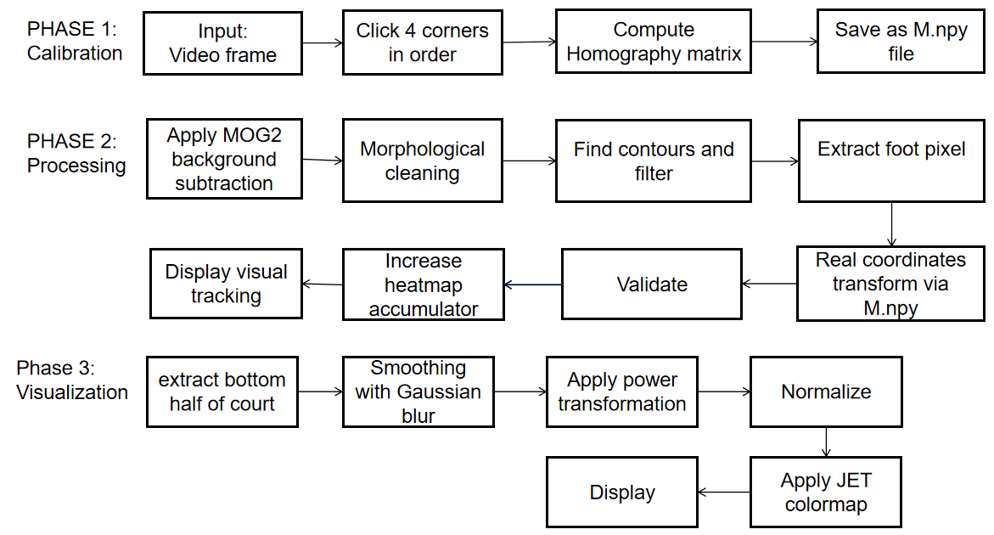
IV. Detail Implementations:
1. Calibration Module (in setup_perspective.py file)
Purpose: Compute the transformation matrix MM that maps camera pixels to real-world court coordinates.
Process:
-Load the first frame of the video.
-Display the frame at a manageable resolution (960px width).
-User clicks the 4 corners of the court in exact order:
+Corner 1: Top-Left (far left, near net)
+Corner 2: Top-Right (far right, near net)
+Corner 3: Bottom-Right (near camera, right side)
+Corner 4: Bottom-Left (near camera, left side)
Each click draws a marker and label on the image.
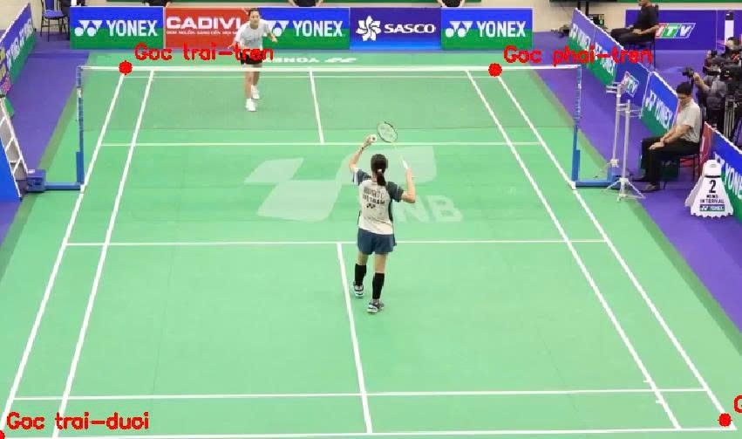
After collecting 4 points, compute:
src = np.float32(points)
dst = np.float32([
[0, 0 ],
[COURT_W, 0 ],
[COURT_W, COURT_H ],
[0, COURT_H ]
])
M = cv.getPerspectiveTransform(src, dst)
np.save(OUTPUT_M, M)
2. Player detection module:
def detect_players(fg_mask, min_area=MIN_AREA):

# Lọc nhiễu morphology
kernel = cv.getStructuringElement(cv.MORPH_ELLIPSE, (7, 7))
mask = cv.morphologyEx(fg_mask, cv.MORPH_OPEN, kernel)
mask = cv.morphologyEx(mask, cv.MORPH_CLOSE, kernel)
mask = cv.dilate(mask, kernel, iterations=2)

contours, _ = cv.findContours(mask, cv.RETR_EXTERNAL,
cv.CHAIN_APPROX_SIMPLE)
boxes = []
for cnt in contours:
area = cv.contourArea(cnt)
if area < min_area:
continue
x, y, w, h = cv.boundingRect(cnt)
if h < w: # người đứng thì h > w
continue
if h < 30: # quá thấp → không phải người
continue
boxes.append((x, y, w, h))
return boxes
3. Coordinates transformation module:
def transform_point(M, fx, fy):
pt = np.float32([[[fx, fy]]])
out = cv.perspectiveTransform(pt, M)
rx = int(out[0][0][0])
ry = int(out[0][0][1])
return rx, ry
4.Heatmap Accumulation
heatmap_acc = np.zeros((COURT_H, COURT_W), dtype=np.float32)

frame_count = 0
positions_log = []
print('[START] Bat dau xu ly video... Nhan Q de dung som.')
while True:
ret, frame = cap.read()
if not ret:
print('[INFO] Het video hoac khong doc duoc frame.')
break
if frame_count >= max_frames:
print(f'[INFO] Du {DURATION_MIN} phut. Dung xu ly.')
break
fg_mask = bg_sub.apply(frame)
boxes = detect_players(fg_mask)
display = frame.copy()
frame_h = frame.shape[0]
split_y = int(frame_h * BOTTOM_HALF_RATIO)
for bbox in boxes:
x, y, w, h = bbox
center_y = y + h // 2
if center_y < split_y:
continue
frame_w = frame.shape[1]
center_x = x + w // 2
if center_x < int(frame_w * CENTER_X_MIN) or center_x > int(frame_w * CENTER_X_MAX):
continue
cv.rectangle(display, (x,y), (x+w, y+h), COLOR_BOX, 2)
fx, fy = get_foot_point((x, y, w, h))
cv.circle(display, (fx, fy), 5, COLOR_FOOT, -1)
rx, ry = transform_point(M, fx, fy)
if 0 <= rx < COURT_W and 0 <= ry < COURT_H:
heatmap_acc[ry, rx] += 1
5. Visualization
HALF_Y = COURT_H // 2
acc_half = acc[HALF_Y:, :] #bottom half of frame extract
blur = cv.GaussianBlur(acc_half, (81, 81), 20) #larger kernal like 81x81 ensure smooth
blur = np.power(blur, 0.4) #power transformation
norm = cv.normalize(blur, None, 0, 255, cv.NORM_MINMAX)
norm_uint8 = np.uint8(norm)
colored = cv.applyColorMap(norm_uint8, cv.COLORMAP_JET)

V. Implementation details
1. Key parameters
Parameter | Value | Description
COURT_W | 610 | In pixels (milimeters)
COURT_H | 1340 | In pixels
DURATION_MIN | 10 | Minutes
MIN_AREA | 800 | Minimum player contour area
BOTTOM_HALF_RATIO | 0.5 | Only 50% of bottom frame is processing
CENTER_X_MIN | 0.2 | Ignore left 20% frame
CENTER_X_MAX | 0.8 | Ignore right 20% frame
2. Perform consideration:
Processing Speed:
-MOG2 background subtraction: ~5-10 ms per frame.
-Contour detection: ~2-5 ms per frame.
-Heatmap update: negligible.
-Total: ~10-15 ms/frame → ~60-100 FPS processing capability.
Memory Usage:
-Heatmap accumulator: 1340 × 610 × 4 bytes = ~3.3 MB.
-Frame buffers: ~2-3 MB per frame.
VI. Code Walkthrough (main.py program)
1. Main processing loop
def main():
try:
M = np.load(M_PATH)
print(f'[OK] Da load ma tran M tu {M_PATH}')
except FileNotFoundError:
print(f'[LOI] Khong tim thay {M_PATH}')
print(' Hay chay perspective_setup.py truoc!')
return
cap = cv.VideoCapture(VIDEO_PATH)
if not cap.isOpened():
print(f'[LOI] Khong mo duoc video: {VIDEO_PATH}')
return
fps = cap.get(cv.CAP_PROP_FPS)
if fps <= 0:
fps = 30
max_frames = int(fps * 60 * DURATION_MIN)
print(f'[INFO] FPS={fps:.1f} | Se xu ly {max_frames} frames ({DURATION_MIN} phut)')
bg_sub = cv.createBackgroundSubtractorMOG2(
history=500, varThreshold=50, detectShadows=True)
heatmap_acc = np.zeros((COURT_H, COURT_W), dtype=np.float32)
frame_count = 0
positions_log = []
print('[START] Bat dau xu ly video... Nhan Q de dung som.')
while True:
ret, frame = cap.read()
if not ret:
print('[INFO] Het video hoac khong doc duoc frame.')
break
if frame_count >= max_frames:
print(f'[INFO] Du {DURATION_MIN} phut. Dung xu ly.')
break
fg_mask = bg_sub.apply(frame)
boxes = detect_players(fg_mask)
display = frame.copy()
frame_h = frame.shape[0]
split_y = int(frame_h * BOTTOM_HALF_RATIO)
for bbox in boxes:
x, y, w, h = bbox
center_y = y + h // 2
if center_y < split_y:
continue
frame_w = frame.shape[1]
center_x = x + w // 2
if center_x < int(frame_w * CENTER_X_MIN) or center_x > int(frame_w * CENTER_X_MAX):
continue
cv.rectangle(display, (x,y), (x+w, y+h), COLOR_BOX, 2)
fx, fy = get_foot_point((x, y, w, h))
cv.circle(display, (fx, fy), 5, COLOR_FOOT, -1)
rx, ry = transform_point(M, fx, fy)
if 0 <= rx < COURT_W and 0 <= ry < COURT_H:
heatmap_acc[ry, rx] += 1
positions_log.append((rx, ry, frame_count))
elapsed_min = frame_count / (fps * 60)
cv.putText(display,
f'Frame: {frame_count}/{max_frames} | '
f'Time: {elapsed_min:.1f}/{DURATION_MIN} min | '
f'Players: {len(boxes)}',
(10, 30), cv.FONT_HERSHEY_SIMPLEX, 0.65, (150,255,0), 2)
h_disp, w_disp = display.shape[:2]
scale = DISPLAY_W / w_disp
display_small = cv.resize(display, (DISPLAY_W, int(h_disp * scale)))
cv.imshow('Badminton Tracking', display_small)
if cv.waitKey(1) & 0xFF == ord('q'):
print('[INFO] Nguoi dung dung som.')
break
frame_count += 1
cap.release()
cv.destroyAllWindows()
print(f'\n[INFO] Tong so diem vi tri da thu thap: {len(positions_log)}')
if len(positions_log) == 0:
print('[CANH BAO] Khong co du lieu vi tri. Kiem tra lai video va M.npy')
return
result = render_heatmap(heatmap_acc, COURT_IMG)
cv.imwrite(OUTPUT_PATH, result)
print(f'[OK] Da luu heatmap vao: {OUTPUT_PATH}')
h_r, w_r = result.shape[:2]
scale_r = HEATMAP_DISP_W / w_r
result_small = cv.resize(result, (HEATMAP_DISP_W, int(h_r * scale_r)))
cv.imshow('Heatmap Ket qua', result_small)
print('Nhan phim bat ky de thoat...')
cv.waitKey(0)
cv.destroyAllWindows()
if __name__ == '__main__':
main()
2. Player detection function (bottom half player on camera side)
def detect_players(fg_mask, min_area=MIN_AREA):
# Lọc nhiễu morphology
kernel = cv.getStructuringElement(cv.MORPH_ELLIPSE, (7, 7))
mask = cv.morphologyEx(fg_mask, cv.MORPH_OPEN, kernel)
mask = cv.morphologyEx(mask, cv.MORPH_CLOSE, kernel)
mask = cv.dilate(mask, kernel, iterations=2)
contours, _ = cv.findContours(mask, cv.RETR_EXTERNAL,
cv.CHAIN_APPROX_SIMPLE)
boxes = []
for cnt in contours:
area = cv.contourArea(cnt)
if area < min_area:
continue
x, y, w, h = cv.boundingRect(cnt)
if h < w: # người đứng thì h > w
continue
if h < 30: # quá thấp → không phải người
continue
boxes.append((x, y, w, h))
return boxes
3. Heatmap rendering function
def render_heatmap(acc, court_img):
HALF_Y = COURT_H // 2
acc_half = acc[HALF_Y:, :]
blur = cv.GaussianBlur(acc_half, (81, 81), 20)
if blur.max() == 0:
print('[WARN] Chua co du lieu heatmap!')
court = np.ones((HALF_Y, COURT_W, 3), dtype=np.uint8)
court[:] = (60, 140, 60)
_draw_half_court_lines(court)
return court
blur = np.power(blur, 0.4)
norm = cv.normalize(blur, None, 0, 255, cv.NORM_MINMAX)
norm_uint8 = np.uint8(norm)
colored = cv.applyColorMap(norm_uint8, cv.COLORMAP_JET)
court = np.ones((HALF_Y, COURT_W, 3), dtype=np.uint8)
court[:] = (60, 140, 60)
result = cv.addWeighted(court, 0.3, colored, 0.7, 0)
_draw_half_court_lines(result)
_draw_legend(result)
return result
4. Smoothtracker filtering program (for the large boundary only).
class SmoothTracker:
def __init__(self):
self.alpha = SMOOTH_ALPHA
self.miss_tol = MISS_TOLERANCE
self._smooth = None # (cx, cy, w, h) float
self._miss = 0
self._last_vel = (0.0, 0.0) # vận tốc cx, cy để dự đoán khi mất

def _clamp(self, w, h):
w = float(np.clip(w, MIN_BOX_W, MAX_BOX_W))
h = float(np.clip(h, MIN_BOX_H, MAX_BOX_H))
return w, h

def update(self, roi_boxes):
"""
roi_boxes : list (x,y,w,h) đã lọc ROI.
Chỉ lấy box lớn nhất (người gần camera).
Trả về (x,y,w,h) đã smooth hoặc None nếu mất quá lâu.
"""
if roi_boxes:
# Lấy box có diện tích lớn nhất
best = max(roi_boxes, key=lambda b: b[2] * b[3])
bx, by, bw, bh = best
bw, bh = self._clamp(bw, bh)
cx = float(bx + bw / 2)
cy = float(by + bh / 2)

if self._smooth is None:
self._smooth = (cx, cy, bw, bh)
self._last_vel = (0.0, 0.0)
else:
a = self.alpha
scx, scy, sw, sh = self._smooth
new_cx = a * cx + (1-a) * scx
new_cy = a * cy + (1-a) * scy
new_w = a * bw + (1-a) * sw
new_h = a * bh + (1-a) * sh
self._last_vel = (new_cx - scx, new_cy - scy)
self._smooth = (new_cx, new_cy, new_w, new_h)

self._miss = 0

else:
self._miss += 1
if self._miss > self.miss_tol:
self._smooth = None
self._last_vel = (0.0, 0.0)
elif self._smooth is not None:
# Dự đoán vị trí bằng vận tốc cuối (coast)
scx, scy, sw, sh = self._smooth
vx, vy = self._last_vel
# Giảm dần vận tốc khi không có detection
vx *= 0.85
vy *= 0.85
self._last_vel = (vx, vy)
self._smooth = (scx + vx, scy + vy, sw, sh)

if self._smooth is None:
return None

cx, cy, w, h = self._smooth
x = int(cx - w / 2)
y = int(cy - h / 2)
return (x, y, int(w), int(h))

VII. Result:
1. Sample tracking visualization:

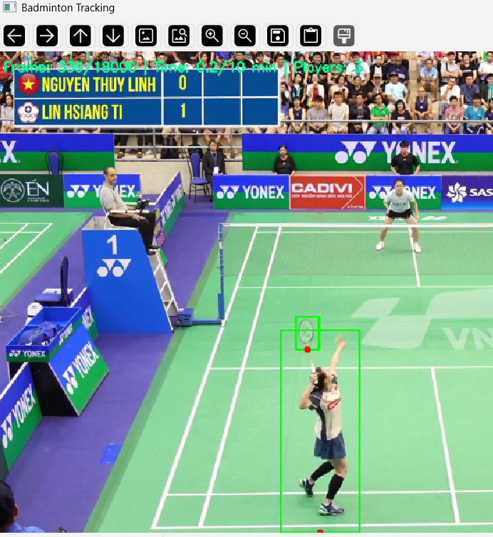
Boundary box: the green rectangular box around detected player.
Foot prints: red dots marking the foot positions
Status bar: turquoise color bar on the top left of screen showing frame count, running time and player detected.
2. Heatmap result:
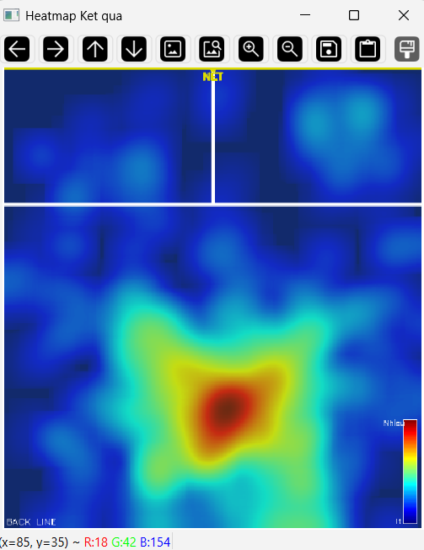
Heatmap after 10 minutes of running
Output file: heatmap_result.png
Court diagram: Green background with white court lines
Heatmap overlay: JET colormap showing density
Legend (on the bottom right): color bar indicate activity level (red = highest, blue = lowest)
Interpretation:
-Red zones: Player frequently moved to these areas (e.g., baseline corners, net area).
-Blue zones: Player rarely moved to these areas (e.g., sidelines, back corners).
-Other colors zones: Moderate activity areas.

